Organization Behavior

1) Neuralink is a neurotechnology company founded in 2016 by Elon Musk and a team of experts in neuroscience, biochemistry, and robotics. The company focuses on developing implantable brain-machine interfaces (BMIs) with the aim of treating serious brain diseases in the short term and achieving human enhancement in the long term.

**Website:** <https://neuralink.com/>

2) Laura Woodruff - Senior Technical Recruiter at Neuralink, (cuase she a have pivotal role in the the people how build the company).

3) **Organizational Characteristics of Neuralink**

**A. Size of the Organization**

* **Number of Employees**: As of 2024, Neuralink employs approximately 500 individuals.
* **Scope of Activity**: Neuralink is a pioneering neurotechnology company dedicated to developing implantable brain-machine interfaces (BMIs). Their primary focus is on creating devices that can assist individuals with paralysis by enabling direct communication between the brain and external technologies.

**B. Organizational Structure**

Neuralink operates under a hierarchical structure led by its founder and CEO, Elon Musk. The organization comprises several specialized teams, each focusing on distinct aspects of their mission:

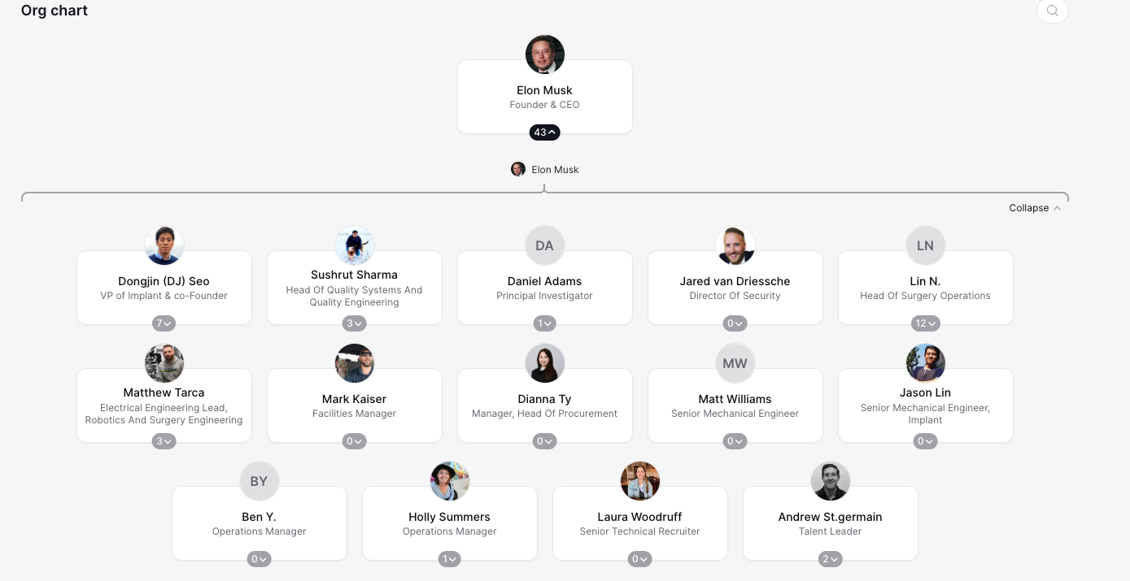

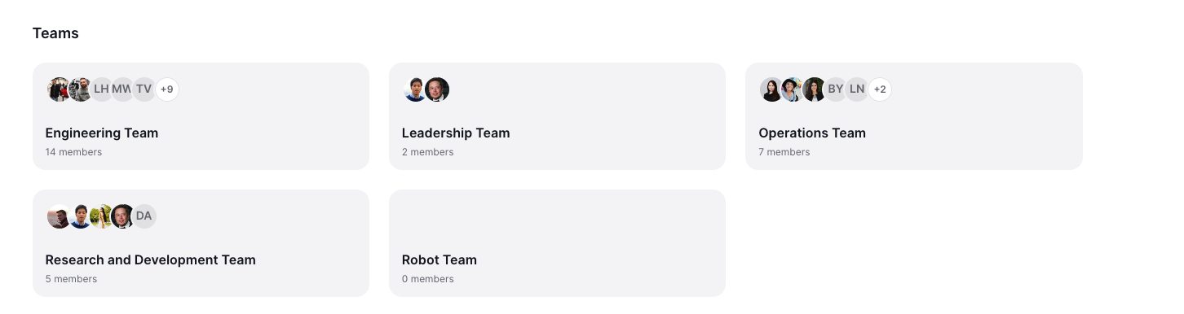

This a general high overview of the company <https://theorg.com/org/neuralink>

**C. Vision of the Organization**

Neuralink's mission is to "create the future of brain-machine interfaces: building devices now that will help people with paralysis and inventing new technologies that will expand their abilities, their community, and their world."

This vision underscores their commitment to developing advanced BMIs to address neurological disorders and enhance human capabilities, ultimately aiming to integrate human cognition with artificial intelligence.

But I this the best is theire linkedin overview

Neuralink is a team of exceptionally talented people. We are creating the future of brain-machine interfaces: building devices now that will help people with paralysis and inventing new technologies that will expand our abilities, our community, and our world. Our goal is to build a system with at least two orders of magnitude more communication channels (electrodes) than current clinically-approved devices. This system needs to be safe, it must have fully wireless communication through the skin, and it has to be ready for patients to take home and use on their own. Our device, called the Link, will be able to record from 1024 electrodes and is designed to meet these criteria.

**Part 3: Efficiency Improvement Recommendation**

**1. Recommendation for Efficiency Improvement**

As an engineer at Neuralink, I recommend enhancing our data compression algorithms to address the significant challenge of transmitting neural data efficiently. Currently, we face the issue of needing to compress approximately 200 MB of neural data down to 1 MB for effective transmission—a compression ratio of 200:1. This level of compression is critical for real-time processing and analysis of neural signals. To achieve this, I propose the following steps:

* **Algorithm Optimization**: Develop and implement advanced compression algorithms tailored specifically for neural data. This may involve exploring machine learning-based compression techniques that can adapt to the unique patterns in neural signals.
* **Hardware Acceleration**: Integrate specialized hardware, to perform compression tasks more efficiently, reducing latency and power consumption.
* **Collaborative Research**: Partner with academic institutions and research organizations to leverage existing expertise in data compression and signal processing.

**2. Justification of the Recommendation**

The justification for this recommendation is based on the following considerations:

* **Technical Feasibility**: Achieving a 200:1 compression ratio is a formidable challenge. Traditional compression algorithms typically achieve much lower ratios, and the requirement for lossless compression adds to the complexity. However, by focusing on the specific characteristics of neural data, we can develop specialized algorithms that achieve higher compression ratios. For instance, identifying and eliminating redundancies inherent in neural signal patterns can lead to more efficient compression.
* **Resource Allocation**: Investing in the development of advanced compression algorithms and specialized hardware will require significant resources. However, the potential benefits in terms of improved data transmission efficiency and reduced power consumption justify this investment.
* **Talent Acquisition**: To successfully implement this recommendation, we may need to recruit experts in data compression and signal processing. Israel is known for its strong talent pool in these areas, particularly among individuals with military backgrounds who have experience in advanced technology development. By expanding our recruitment efforts to include Israeli engineers.

**Appendix A: Interview Transcript**

*Interviewer:*  
Hi, Laura! Can you hear me okay?

*Laura Woodruff:*  
Yep, I can hear you! Thanks for setting this up—happy to be here.

*Interviewer:*  
Great! Thanks for joining me. Could you start by introducing yourself and telling me about your role at Neuralink?

*Laura Woodruff:*  
Sure! I’m Laura Woodruff, and I’m a Senior Technical Recruiter at Neuralink. My job is all about finding and attracting the best talent—engineers, neuroscientists, even marketing folks—to help Neuralink achieve its mission. I’ve been here for a little over two years now, and before that, I worked at LinkedIn and TEKsystems, which were incredible learning experiences that really shaped how I approach recruiting and team-building.

*Interviewer:*  
That’s impressive! What do you enjoy most about working at Neuralink?

*Laura Woodruff:*  
Honestly, it’s the mission. Helping people and pushing the boundaries of technology is something I’m really passionate about. And, of course, the people here are just brilliant—it’s inspiring to work alongside such innovative thinkers. I also love how recruiting at Neuralink feels so meaningful because every hire makes a direct impact on our projects.

*Interviewer:*  
That sounds fulfilling. Can you share a bit about how your experience at LinkedIn and TEKsystems has influenced your work at Neuralink?

*Laura Woodruff:*  
Absolutely. At LinkedIn, I worked on building the first global economic graph, which gave me a deep appreciation for data-driven decision-making. That experience really helped me think about recruitment in terms of metrics and strategy. At TEKsystems, I trained and mentored new recruiters, which taught me the importance of communication and team development. Both roles gave me the foundation to adapt quickly and solve challenges creatively.

*Interviewer:*  
Wow, that’s a unique combination of skills! What’s a specific management practice at Neuralink that you think works particularly well?

*Laura Woodruff:*  
One thing I love is the emphasis on collaboration. At Neuralink, we often bring cross-functional teams together—even during the hiring process. For example, when recruiting engineers, we involve team leads early on to make sure we’re not just filling roles but finding the perfect fit for the team and culture. That kind of proactive alignment is something I haven’t seen at many other companies.

*Interviewer:*  
That’s a great approach. On the flip side, have you encountered any challenges in your role?

*Laura Woodruff:*  
Oh, definitely. One of the biggest challenges is keeping up with the speed of innovation here. Things move quickly at Neuralink, so we’re constantly adjusting our hiring strategies to match the pace. It’s exciting, but it can also be, well, a bit of a balancing act to ensure quality and speed.

*Interviewer:*  
I can imagine. How does Neuralink use data in its recruitment process?

*Laura Woodruff:*  
We rely on data a lot! For example, we track metrics like time-to-hire, candidate engagement, and success rates post-hiring. Recently, we introduced a predictive analytics tool to identify trends and help us make better decisions earlier in the process. Data is a game-changer because it takes some of the guesswork out of hiring.

*Interviewer:*  
Can you give an example of a recent data-driven project?

*Laura Woodruff:*  
Sure! One big project was optimizing our interview process. Using past data, we found that candidates were getting stuck at the technical screening stage, which slowed things down. We streamlined the process by combining technical interviews with real-time coding challenges, which cut the average time-to-hire by 20%.

*Interviewer:*  
That’s amazing. What about organizational changes—has Neuralink undergone any recently?

*Laura Woodruff:*  
Yeah, in 2024, we overhauled our onboarding program. Before, it was more one-size-fits-all, but we realized that different roles needed tailored onboarding experiences. So, we created customized tracks for engineering, neuroscience, and operations, which included specific workshops and mentorship programs.

*Interviewer:*  
How would you analyze that change?

*Laura Woodruff:*  
Using Kotter’s 8-Step Change Model, it went something like this:

* **Create urgency:** We showed leadership how poor onboarding was slowing productivity.
* **Build a team:** We pulled together people from HR, operations, and engineering to revamp the program.
* **Develop the vision:** We outlined clear goals—faster integration and higher engagement.
* **Communicate the change:** We held company-wide meetings to explain why onboarding was being updated.
* **Empower action:** Teams were encouraged to provide feedback to refine the program during the pilot phase.
* **Celebrate wins:** After seeing improved productivity, we highlighted the success across teams.

*Interviewer:*  
How did it improve efficiency?

*Laura Woodruff:*  
We saw two major improvements: new hires were fully onboarded 30% faster, and turnover in the first six months dropped by about 15%. The feedback has been overwhelmingly positive.

*Interviewer:*  
This has been so insightful, Laura. Thank you so much for your time!

*Laura Woodruff:*  
Of course! Happy to help, and, hey, if you’re ever thinking of getting into recruitment or tech, just let me know!

Peer assessments

**Tal Dvora's Assessment of Shaked**  
*Working with Shaked on this project was a fantastic experience. Shaked demonstrated exceptional commitment to every aspect of the project. From gathering data on Neuralink’s organizational structure to analyzing the interview insights, their attention to detail was remarkable. Shaked's ability to simplify complex concepts, such as Kotter’s Change Model, made our discussions and final presentation much clearer. Moreover, their proactive approach to dividing tasks ensured that we stayed on track. I particularly appreciated Shaked’s innovative idea to incorporate Israeli talent in the recommendation, which added depth and originality to our work. Overall, Shaked was an invaluable teammate, and I look forward to collaborating with them again.*

**Shaked's Assessment of Tal Dvora**  
*Tal was an amazing partner to work with on this project. Their thorough research on Neuralink’s mission, vision, and structure laid a strong foundation for our report. Tal brought incredible creativity, especially in summarizing the interview transcript and transforming it into clear and engaging insights. Their technical expertise was instrumental in shaping our efficiency improvement recommendation, particularly the section on data compression algorithms. Tal also ensured that our final output was polished and professional, paying attention to even the smallest details. It was truly a pleasure to work together, and Tal’s collaborative attitude made the process enjoyable and productive.*